‘Air Guitar-iste’ preamp build notes

Needless to say the disclaimer is that you do all this at your own risk and are fully responsible for the results. If you’re not sure then don’t attempt it.

Ok onwards. Well this is all pretty self explanatory. But…

1 Make the pcb. You’ll need to print the pdf of the pcb onto either OHP film or best get a sheet of reprographic film run off from a print shop that still produces them. Then expose this onto a sensitised photoboard (try and get the emulsion side of the film in contact with the board otherwise light leaks through and narrows the tracks and make sure its fully in contact with the board at all places. 1-1.5 hours in sunlight is sufficient to expose a board fully, a 20-30second dip in seno developer solution, wash and etch in ferric chloride for 30-60minutes till all the copper’s etched away. Then use paint stripper to get the photoresist off, drill out the holes with a 0.8 - 1mm drill bit, cut to size with a hacksaw or something and voila, the board is ready. Note the veropins are a 1mm hole.

See components page for pcb materials available from mega electronics cheaply.

PCB MAKING EQUIPMENT
 | ferric chloride pellets | 50g packets of senso developer for which makes up 1L of solution, Look under 'pcb chemicals' | Mega Electronics | (600-008) | £1.05
 | developer | 250g packets of ferric chloride crystals, Look under 'pcb chemicals' | Mega Electronics | (600-011) | £1.60
 | pcb boards | Single and double sided pcbs of various sizes, coated and uncoated, from 1oz to 2oz copper. Look under 'PCB laminates' to find the boards | Mega Electronics | Various | various
 | Developing Trays | Trays for develping and etching the pcbs. Look under 'sundries and accessories' | Mega Electronics | 900-011 | £2.05

Note the layout has a clear effect on the sound so this has very tight grounding and star supply. The improvement in sound over the layout of a standard 32.5 is about half that of the Mr Tibbs split ground mod for those who know. Brings a lot more coherence and involvement to the sound. See the Naim preamps and you’ll see how grounding gets tighter as you go up the ladder. That of the 102 would seem to be a prime example with what can only be described as purposely designed slack grounding.

2 stuff the pcb.
As far as parts go the most critical and influential on the sound are definitely caps probably followed by ICs and then transistors and resistors.

Anyway stuff with the smallest components first and move up to the biggest last of all or its going to be tricky.

Resistors: Vishay dale RN60 are very nice. They do give a slightly smoother detailed sound though are not hypercritical. The only real source I’ve found is Mouser in the US but they are a good supplier and you can buy them individually which makes them cheap overall. Otherwise Naim use BC components SFR25 which are also fine though you can only buy in 50s from farnell. If using the BC components you will probably want to use Welwyn RC55Ys in the feedback loop (R10 and R13) as these do give a small improvement with a slightly sharper sound. The feedback resistors are the most important ones to worry about probably followed by the input bias dividers (R2,3,4).
Transistors: BC550/560 are fine transistors and I can’t really hear any great difference between them and naims original components. I don’t think these are critical components or they’re pretty good substitute if they are.
Coupling caps: these are fairly critical and fiddly to get right. The SMRs are the best I’ve tried and, in the context of this preamp as a whole, are a finely balanced implementation. They can sound a bit ‘grey’ in circumstances but in the context of the ‘Air Guitar-iste’ give a wonderfully tight, clear and open sound as other factors in the pre balance and compensate meaning the overall sound is full and rich. The 10uf on the output has no real viable alternative though If I was going to, I’d try a 10uf multicap ppfx-s polypropylene/tin foil (huge). Input cap is 2.2uf SMR, again damn good. The only component that may be superior (heard some good reports) is a Multicap RTX polystyrene and foil for the input coupling cap, available from parts connection in the US. They are large and expensive though. Use something in the 1-3uf range in place of the input 2.2uf SMR. I’ve used SMRs down to 1uf with no real ill effects but 2.2uf gives a very minute more fullness in the bass.
If for any reason you need to tune the preamp i.e you feel the treble is somwhat harsh or glassy, my suggestion is replace initially the input, and if that’s not enough then also the output SMRs with 10uf tants or 10uf elna silmics. You will loose detail, bass tighness, openess and some rythmic exactitude but IMO it ‘dithers’ the treble and takes the edge out of it. From my experiences over time though this is down to inadequacies in source; more specifically midrange CD players will probably be your culprit. If your CD player is up to scratch, treble will be clean and play beautifully and fatigue free, and if the player is really cheap there won’t be enough defined treble to cause offence.
Decoupling cap: this is extremely critical: The 5.6uf Mundorf Mcap is the best I’ve tried by a long way and happily pretty cheap. Beats expensive Audyncap plus, smrs etc. It has a wonderfully full bass and just adds a huge sense of groove and drive. The only things that might beat it are Mulitcap PPFXS tin foil and polypropylene or again 3uf Mulitcap RTXs again available from Parts connection in the states. Again these are huge and very expensive and may not be better so unless you want to experiment with very pricey components, stick with the mundorf. Also 3.3uf is probably fine but I’ve only tried the 5.6uf properly so that’s what I recommend. Up to 10uf seem to be fine when I did a quick non-critical test listen.
Constant current diode: use either the 56k2 resistor for R12 or substitute with the J510 ccs diode. To be honest couldn’t hear much difference but it’s an option to try for a laugh. Recommended by Les W of avondale to try out though.
1uf decoupling cap: This gives an improvement making things smoother and gives better flow to the music. Its not supercritical so a good 1uf film will do. I found 47uf electrolytics as recommended elsewhere slightly worse than none at all in this context so stick with a film cap which IS better than none. The idea is to smooth abberations in the constant current source. By all means play with larger values if you wish but by my reckoning theres only about 0.5mA though here so 1uf should be plenty.
0.1uf decoupling cap: This is not critical and gives a minute improvement but don’t loose sleep over it. Again smooths the voltage bias divider.
47uf feedback cap: This is extremely critical again. Stick with the box polyester as specified. I’ve tried polypropylenes and they are more detailed but tear the fabric of the music apart leading to boredom. The polyesters are wonderful at making the music gel together for some reason and I suspect it may be the low inductance box construction that is important. If this is impossible use a 50V 47uf Elna silmic but the polyesters are a fair bit better.

Superregulators:
Power is what makes this preamp special and ALW superregs are utterly superb.
Run these at 30V if possible (means your raw dc psu must output in the range 35V –40V dc) but down to 24V if not. The higher voltage sounds better.
connect these from the neutrik socket via 30A (~2.5mm2) hookup wire for low impedance. Its probably a good idea to make a twisted pair with the ground wires as much as possible.
Use the remote sense connections both for ground and the positive rail to make the most of the star earthed pcb construction. I actually use some fat coax cable and run the sense line through the central core so the actual output supply acts as a shield for the sense. It may be a nonsense idea but it works. If using separate wires its probably sensible to make twisted pairs with them again. Some 1mm2 hookup wire is probably fine here.
Its may also be worth decoupling the input of the tracking LM317 regulator with a 0.1uf 50V tantalum or 100uf, 63V electrolytic if possible- the lm317 datasheet and the orginal Walt Jung article does recommend this if the reg is more than 6 inches from the reservoir caps which they are.
I would leave C5 IN (100uf) on the regs as when I tested leaving this out, there was to my ears a bad loss of bass drive and involvement in this context. Please try for yourself though to verify.
C7 must definitely stay OUT though.
Mount the superregs directly to the tray (have them sticking up vertically) so there is space for the board.

Why no (time aligned or just simple) buffer boards
The pre is built around the basis of only using naim-style gain boards (and thus only 2 superregs are used) but no buffer boards. This is because although there are gains to be had using time aligned buffer boards (good, more detail, cleaner), or removing the old style unity gain buffers (very minor) these is insignificant compared to the huge gains to be had from powering each regulator (and thus channel on the gain board) from its own winding on the transformer. It just gives a much bolder, bigger and cohesive sound- more majestic and authoratative- Fortuitously this also saves on the cost of regulators.
To use buffer boards and get the same level of quality I suspect you would have to use a transformer with 4 windings, 4 reservoir caps, 4 superregs etc etc….. and I doubt you’d get a huge improvement to justify the huge increase in construction cost. I’m not going there anyway.

OK, now to the optional bits. If you’re hacking an existing pre such as a 32.5, you can leave the parts below in place (ie output relay, volume and balance pots and input selector) which will save you time and money so you’re essentially finished. Just cut away the mother board where the red lines indicate then insert the Air Guitar-iste board and superregs in the space vacated and you’re away. This leaves all the control elements and output relay intact.

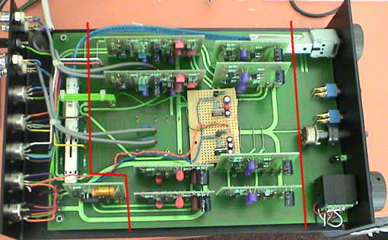

Wiring up

You tap the signal from the input selector from the two tracks in front of the phono sockets (use a mulitmeter to check continuity from the input din sockets to select the correct tracks) so drill two quick holes and solder in some vero pins. Same applies to output from the preamp board which goes to the relay input pins. Just drill 2 holes on the boards and away you go.

This is the route I’ve taken. However if you’re building from scrach then these are some suggestions for the control and protection components.

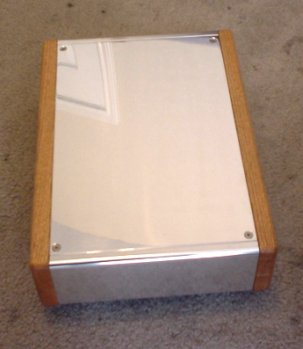
The CH3 chassis

Output relay
If you’re using the case of a naim pre, I’d leave the output relay in and just use that. Just give it at least 24V dc and a connection to star ground.
You CAN leave it out altogether, though always switch the pre on for 10-20 seconds before the poweramp or you may blow your speakers with the swichon thump. Alternatively just stuff and use the relay section of the Air Guitar-iste board. I’ve checked this thoroughly though not tested it personally. Its been included along with its own LM317 regulator to tap off the raw dc because someone will feel more comfortable with it this way. To be honest I’ve tapped the output of one of the superregs to feed this with no discernable channel differences so up to use wether you stuff the reg parts or not. Either way it also feeds the 3k3 resistor (R27) which supplys the power LED. On the relay I’ve provided a separate ground the signal output resistors. Just feel more comfortable that way though sonically it may be unnecessary.
If you’re hacking a 32.5 the LED needs a 24V source and ground connection too, don’t forget.

Wiring up the LED(This might also come in useful for some):
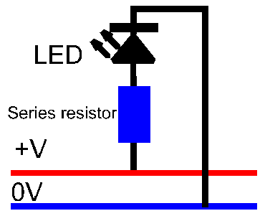

You will need to know the If (mA) of the LED and it's PIV (peak inverse voltage). This information should be given in a suppliers catalogue. The LED will need a resistor in series with it and to calculate the value of that resistor, the formula is:

R=(V-PIV)/If (where V is the rail voltage supplying the LED)

As an example lets say that you want to use a nice blue LED (Farnell order code 233-493) with a PIV of 4.5 volts and If of 30mV and your voltage rail is 26 volts. So you will require a series resistor of the value (26-4.5)/0.0030 = 7167. The nearest standard value to this is 7500 (7K5) and it won't do any harm to operate the LED at just below it's maximum voltage.

The series resistor can go before or after the LED, it makes no difference but should be rated at 0.5W or higher. The anode of the LED is connected to the postive OR NEGATIVE rail (in a psu to the -ve terminal of the bridge) and the cathode to the zero volt rail.

Balance pot
On the 32.5 the balance pot is a 5K one though it looks a pretty nasty affair. If you want to leave it out alltogether then see that R17 (the balance pot padding resistor before the input coupling cap) is utilised. Try it in and out anyway to see if it makes a difference- the sound may be fine with it either way. If you use a balance pot then do not use R17 so simply solder in a link wire.
The balance pot I’ve specified as a potential solution is a 10k alps blue pot again. This may or may not be ok soundwise as its twice that in a 32.5 so up to you to try out but alps and elma do several 5k types which are probably fine. Make sure they’re stereo though.

Input selector
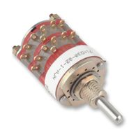
Again I’ve not used these before but Grayhill seem to have a good name and they look pretty solidly contructed so I’ve specified that as a suggestion. It has a 0.25” mm shaft to fit the knob specified. 6 poles for the 6 inputs and 2 wafers for each channel. If you want more inputs then you’ll need more poles on your selector switch.

Control knobs
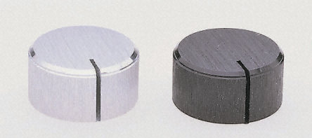
If you go for the suggested IAG audio CH3 case, the silver brushed aluminium knob would probably be more pleasing to match the silver front though the anodised black ones are very nice in the flesh too.

Tape out option
If you want a tape out option, I see no reason why not to add a switch which taps the signal line and feeds directly to the tape output pins when swiched in. Just use one of the ones on the front panel if you’re hacking a 32.4 or whatever otherwise add one (See block diagram). Not tried this personally though so you’re on your own. It effectively means your source will drive your tape deck directly though so this probably won’t give absolute optimum sound quality but then the Air Guitar-iste IS a stripped down pre.

And that’s about it ….. apart from the sound.
And it’s a bloody nice one too, with an extremely tight, deep and rythmic bass that just has bags of drive and groove factor. The whole sound is considerably more transpartent and dimensional than your standard naim pre and it has loads of detail that does not overwhelm the music. Coherence and a sense of unity in the music (that you’re listening to a performance not several independent players who happen to be in the same room) are exceptional and there is a real visceral involvement at a fundamental emotional level. Sound stage is huge and spreads way to the side of the speakers while being rock solid with a solid center image. Timing is laser sharp and little rythms are crystal clear. Everything is easy to hear and presented in an effortless way. It’s just an extremely elegant yet rapacious beast which never fails to bring out the best in any recording, good or bad, though you can tell the difference between recordings with ease.

And thanks to all those Pink Fishers who made it possible. I’m happy anyway.
Cheers
Cedric

