RAW DC PSU- Build notes

The key aspects to the raw DC supply are as follows:

Earthing: Ensure the case and every panel on the case is is fully mains earthed as you are dealing with potentially leathal mains voltages. So see that the mains earth wire is a good thick gauge wire. Use one of the eyelets, clip it and squeeze the hole smaller then you can screw it to the case. Check with a voltmeter there is 0 ohms resistance between all panels of the case and the mains earth. If you have any doubt about this aspect do not build this project as mains voltages are potentially lethal and you build at your own risk.

The quality of the transformers is critical. Toroids are very poor; I’ve tried several of varying sizes and manufacturers all of which failed to bring any improvement. I can personally recommend R core transformers from hifi tuning or reputedly even better are C core transformers from Avondale Audio. These are probably your most reliable bets. However you need 2 CENTERTAPPED WINDINGS in total. This is critical.
(Transformer design is a bit of a murky subject but (amorphous) C cores, low impedance secondaries, split bobbins, interwinding shielding, low interwinding capacitance, centertapped windings are all key words to be looking for.)

Note: I’ve not used the avondale parts so check they will fit in the case before buying.

Good quality reservoir caps are required and I suspect low ESR is a critical factor. Kendeils are very nice and probably best though I’ve used BHC aerovox ALS30A happily as well. No great difference between them IMO. Value is not critical either: I’ve used from 10,000uf to 33,000 uf with no great difference in sound so 22000 seems a happy medium.

Rectifiers are not particularly critical either. Silicon bridges are easy to use and barely more expensive than making up a shottky bridge. Shottkys are slightly better and the way to go if you can easily etch half bridge pcbs otherwise just go for good high current silicon bridges such as from International Recitifiers.
It is however recommended to mount the rectifiers CLOSE to the caps to keep the wiring between bridges and caps very small as there are high currents travelling through these connections so resistance is an issue. Use good 30A hookup wire.

Grounding. This is critical. Do NOT follow the naim method of joining the ground connections between the caps. The 2 psu channels should remain totally separate and are earthed only at the PREAMP. This gives a big lift in sound quality over the naim method (thanks mr tibbs).

IEC inlet; Its convienient to have a joint switch/fuse/IEC socket inlet. However you can mount separate ones if you want. I recommend SCREW IN sockets as you need to cut very precise holes for snap in sockets which is beyond most DIYers. Note, with the IEC socket listed, the pins are connected by punched metal strips. I recommend soldering the joins with a 40W iron to ensure a solid and low impedance connection.
Also use a high voltage heatshrink or pin boots to cover any exposed metal parts after soldering your transformer primaries to the IEC inlet as these are at high voltage.
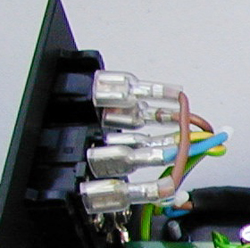

Fuse must be slow blow or it will ‘go’ at every switch on due to the high inrush current of transformers charging the reservoir caps. Inrush currents can be up in the hundreds of amps.

For hookup wire I recommend good 30A or 2.5mm2 stuff. Low impedance is important in a psu to dynamics and mOhms count here. Current spikes can be high at moments when the diodes switch.

For connectors I recommend neutrik speakon. They have a very low contact impedance of <3mOhm, are very secure and very simple to wire up. None of the messing around with Burndy connectors and pins etc.

For umbilical use a good 2.5mm2 or even 4mm2, 4 core control cable. Ones by Raydex for example are fine. Buy over 1m as you need to connect the cores at one end of it direct to the reservoir caps

The led is optional: wiring is as follows:
LED panel light
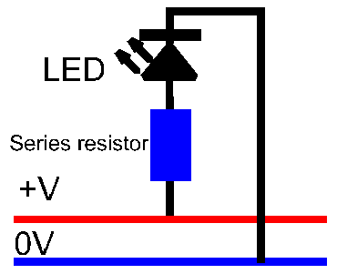 | You will need to know the If (mA) of the LED and it's PIV (peak inverse voltage). This information should be given in a suppliers catalogue. The LED will need a resistor in series with it and to calculate the value of that resistor, the formula is:  R=(V-PIV)/If (where V is the rail voltage supplying the LED)  As an example lets say that you want to use a nice blue LED (Farnell order code 233-493) with a PIV of 4.5 volts and If of 30mV and your voltage rail is 26 volts. So you will require a series resistor of the value (26-4.5)/0.0030 = 7167. The nearest standard value to this is 7500 (7K5) and it won't do any harm to operate the LED at just below it's maximum voltage.  The series resistor can go before or after the LED, it makes no difference but should be rated at 0.5W or higher. The anode of the LED is connected to the postive OR NEGATIVE rail (in a psu to the -ve terminal of the bridge) and the cathode to the zero volt rail.

